Sprint 1 Plan

Flsh

10/11/17

Release 0.0

Sprint 1 Plan

**Goal:**

The goal of sprint 1 is to connect the server, database, Foundation API, and Google Maps API so that a user would be able to access a working website.

**User Stories:**

US1: As a user, I want to be able to access a working website.

Task 1: github server (4)

Task 2: database (4)

Task 3: Familiarize ourselves with the Foundation API (6)

Total for user story: 14 hours

US2: As a user, I want to view/navigate a map to view my surrounding area.

Task 1: Familiarize ourselves with the Google Maps API. (6)

Task 2: Implement a basic map into the website. (6)

Total for user story: 12 hours

**Team Roles:**

Jessica Del Rio Product Owner, Developer

Emily Bettencourt   Initial Scrum Master, Developer

Sabrina Leano Developer

Oliver Ma Developer

**Initial Task assignment**

Jessica Del Rio US1: Task 1, Task 3

Emily Bettencourt   US1: Task 2

Sabrina Leano US2: Task 1, Task 2

Oliver Ma US1: Task 3

**Initial Burn up chart**

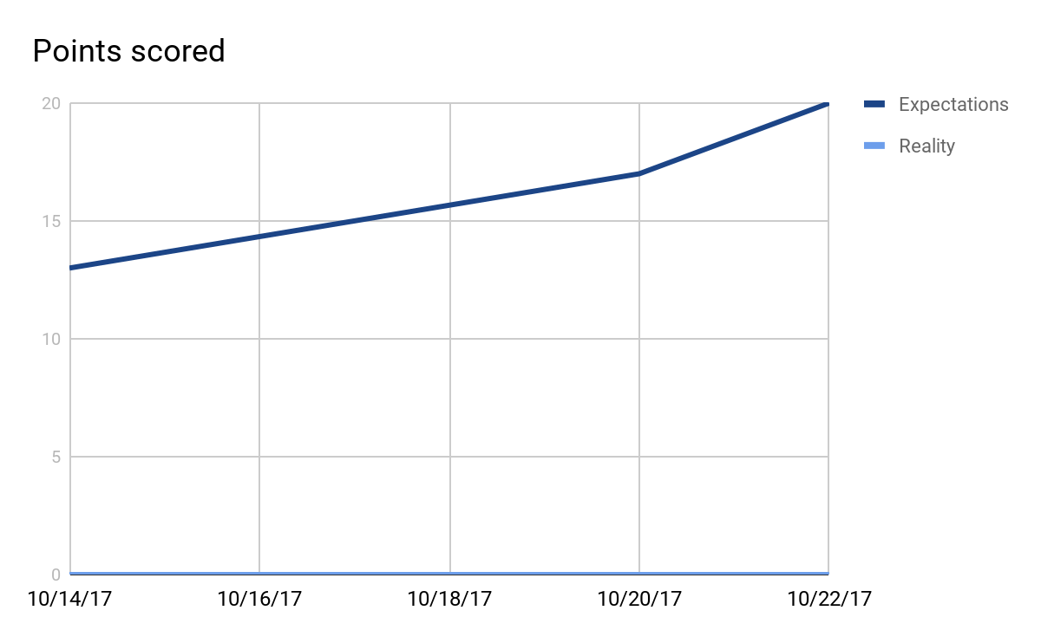

**Initial Scrum Board**

<http://scrumblr.ca/Flsh>

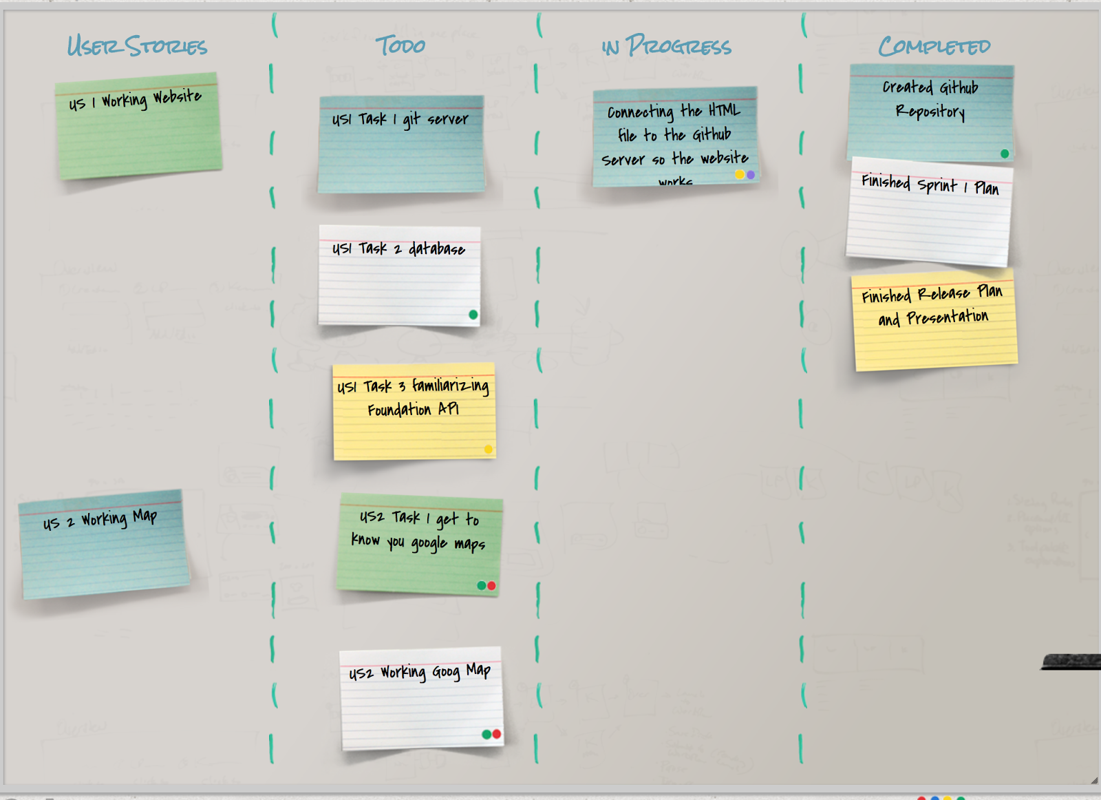

**Scrum Times**

TWTh: 3pm - x